Amend the equipment title, safety signs (page 2) and example text in the tables. Delete italic prompts and page 2 before saving.

STANDARD OPERATING PROCEDURE

HOT AIR GUN

DO NOT USE UNLESS YOU ARE TRAINED, COMPETENT & HAVE PERMISSION

What warnings and/or protective measures must be taken when using this equipment?

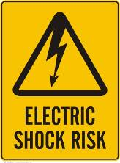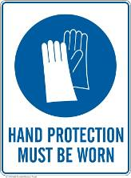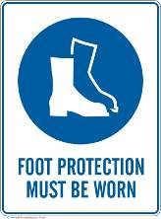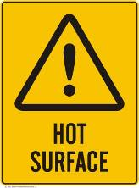

POTENTIALS HAZARDS………… ………………… ……… … ………. .…

What are the potential hazards? What can go wrong? Are there known ways in which the equipment could fail generating a hazard? Are there any by-products from use (i.e. eye hazards, breathing hazards)?
Hot element, surfaces and airflow | Eye injuries
Burns | Fire
Toxic Fumes | Slip & trip hazards
Electric shock

PRE-OPERATIONAL SAFETY CHECKS do not use defective or faulty equipment Equipment is sometimes not used for long periods. What must be done to ensure that it is always as safe as possible to use?
1 | Examine the power lead and gun for damage, do not use if damaged.
2 | Ensure you are familiar with all the equipment controls.
3 | Ensure the cord does not create a slip/trip hazard.

OPERATIONAL SAFETY………… ………….… ……………… ………… …………..
Note things that you must check whilst using the equipment. Must you be aware of gauges providing important operational information? How must you respond to certain things if they occur?
1 | Do not use the Hot air gun in the proximity of any flammable materials, liquids, gases or vapours.
2 | Never touch the HOT Nozzle with clothing or skin.
3 | Never direct the air flow towards anyone.
4 | Never use the Hot air gun if it is wet, over a sink or vessel or puddle of water

POST-OPERATIONAL… ………………………………… … ……………… …………

What must be done to ensure that the equipment will be ready for safe use next time it is required? Is there routine maintenance to do after use? What tidying up is required when you have finished using it?
1 | Switch off before putting the gun down and allow gun to cool down before storing.
2 | Leave the equipment in a clean and tidy state.
3 | Never leave the hot air gun unattended when switched on or when switched off but still HOT.

FORBIDDEN this equipment must only be used for the purpose for which it is intended

Are there examples of known prohibited uses? Could there be temptation to use the equipment for jobs it is unsuitable for.
1 | Do not use the Hot air gun on lead based paint or Western red cedar wood or any other materials which give off toxic fumes when heated.
2 | Never block the inlet grill or obstruct the airflow while in operation

This Standard Operating Procedure does not necessarily cover all possible hazards associated with the equipment. It should be used in conjunction with other references. It is designed as an adjunct to training and to act as a reminder to trained, competent operators.

ASSESSMENT DATE:  / /  IF USED AS RECORD OF COMPENTENCY | Verified by Supervisor: |  | (name & signature)
 | Competent operator: |  | (name & signature)

PLEASE COPY APPROPRIATE SIGNS TO THE PAGE ABOVE. DELETE REMAINDER TO LEAVE A SINGLE PAGE STANDARD OPERATING PROCEDURE. FOR ADDITIONAL SIGNAGE PLEASE CONTACT SAFETY AND HEALTH.

