REV PROJECT GETZ INFORMATION SHEET
This sheet to be kept by inductee

Instructor Name | Instructor Contact Information

Supervisor Name | Supervisor Contact Information
Thomas Braunl

Driving an Electric Vehicle
Driving an electric vehicle is almost identical to driving a petrol/diesel equivalent. There are only a few differences to note.

Before Driving the Getz
Check the following:
- The vehicle and you are in compliance with the vehicle usage procedures (R01).
- You have read and understood the induction documents (F03).
- The vehicle is not charging and the charging door is shut.
- Emergency stop button is not down
- The vehicle is sufficiently charged (see Battery Level).
- The charging cables are stored in the vehicle.
- You have the ability to contact support if necessary (a mobile phone and contact information)

Starting the Vehicle
- Put gear shifter into neutral.
- Enable drive system by turning the key in the ignition.
- Move gear shifter to 2nd gear for forward driving (or R for reverse) while braking
- Slowly accelerate.

If the vehicle does not start check the following:
- The vehicle is not currently charging and the charging door is shut.
- The emergency stop button is not down.
- The vehicle does not make much noise when turned on: try driving the vehicle slowly.

Battery Level
Electric vehicles use battery packs to supply energy to the vehicle engine. You can determine the current battery level by using the battery meter in the centre console of the Getz.

Before you drive, you should check your vehicles battery level. The range of the Getz is 60km, so with a battery level of 75% you should be able to travel 45km.

The battery monitor has several different menus that can be scrolled through using the arrow buttons. The Getz battery monitor displays the following information:

- Battery Level: as a percentage symbol (%)
- Time: in hours (h)
- Battery pack voltage: in volts (V)
- Amperage: in amps (A)
- Amp hours: as amp hours (Ah)

When not using the vehicle for a long period (over a week), keep an eye on the battery voltage. The Getz battery pack should not go below 140V, if it does: report the fault immediately to a REV instructor or the REV Project supervisor.

Transmission
The Getz uses a clutch-less manual, to change gear simply change with the gearstick.

When driving the Getz, it is recommended to use only third gear to drive forwards, and reverse to drive backwards. Although you may find second gear is necessary for hills and forth gear is necessary for higher speeds (freeway/highway). In converted electric vehicles first and second gears are usually not needed because electric engines can create their maximum torque instantly and have a higher redline than petrol engines.

Important: The Getz is not an automatic and doesn’t have creep. On hills you may have to perform a hill start using your handbrake as your foot moves from the brake to the accelerator to prevent the vehicle from rolling.

Vehicle Charging
The electric vehicles should always be left charging where possible. The batteries can be damaged if the vehicle is left uncharged for a long period (over a week).

The Getz can be charged using a 15 Amp charging cable and socket or at the REV Project charging stations using the station cable and yellow RFID tag (attached to the vehicles keys).

The emergency stop button must not be down in order for charging to take place.

The charging locations for UWA are shown on the map below:

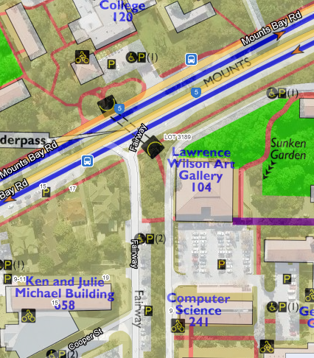
UWA Charging Station
Michael Building Basement

To charge in the Michael building basement (or at a 15 amp socket):
A 15 Amp plug is provided on the upper basement floor of the UWA Michael building, accessible from Fairway Street using the tag attached to the vehicle keys. The REV Project parking bays are located left of the gate when entering the car park.
- Park and turn off the vehicle
- Open the fuel hatch by pulling up the leaver underneath the driver’s seat on the right.
- Ensure the 15 amp socket located on the wall of the basement is off before plugging the cable in. Use the 15 amp extension cable (similar to a normal electrical extension cable) in the boot of the Getz to connect the vehicle from its plug inside the fuel hatch (left side of the car, near the rear) to the 15 Amp socket on the wall.
- Turn on the 15 Amp socket.
- Check the battery management system in the car’s boot on the left. The LED labelled “charging” should be on and green. If the system is off (no LED lights are on), turn it on.
- If the red error light is showing, or you have any other problem, report the fault to a REV instructor or the REV Project supervisor.

To charge at REV Project Charging Stations:
The UWA charging station located in the South-East corner of car park 20 (next to the computer science building in the north-west corner of the Crawley campus).
- Park and turn off the vehicle
- Open the fuel hatch pulling up the leaver underneath the driver’s seat on the right.
- Collect the charging station cable (large grey plug on one end) from the boot of the Getz and connect it to the plug in the fuel hatch (left side of the car, near the rear).
- Tag onto the station by holding the yellow RFID tag on the vehicles keys to the black card reader on the charging station. If the station fails to recognise the tag, try again ensuring you hold the tag against the card reader until authentication is complete.
- When the station reads please insert plug to start charging, insert the large grey plug into the station. The cable should lock and the station should turn green and say “charging in progress”.
- Check the battery management system in the car’s boot on the left. The LED labelled “charging” should be on and green. If the system is off (no LED lights are on), turn it on.
- If the red error light is showing, or you have any other problem with the vehicle or station, report the fault to a REV instructor or the REV Project supervisor.

You can check your vehicle is charging by reading the battery pack amperage on the battery meter (see Battery Level). The Getz should read 13A when charging correctly. If the vehicle is not charging correctly: report the fault immediately to an REV instructor or the REV Project supervisor.

Breakdown Procedures
In the event the electric vehicle has broken down, contact a REV instructor or the REV Project supervisor. If they cannot be contacted, call the RAC on 131111.

Emergency Procedures
In the event of an emergency it is important put the lives of yourself and others first.

Emergency Stop
To perform an emergency stop and cut off all power from the batteries to the vehicle, press the large red button in the centre console. The emergency stop is sometimes left down, to unlock the emergency stop button, use the key provided with the vehicles keys.

Vehicle Fire Extinguisher
The Getz fire extinguisher is located in the vehicles glove compartment.

Michael Building Basement Fire Extinguisher
The fire extinguisher for the Michael building is located in the centre of the eastern wall of the basement.

