REV Project Jet Ski Charging

- Flip the rotary switch.
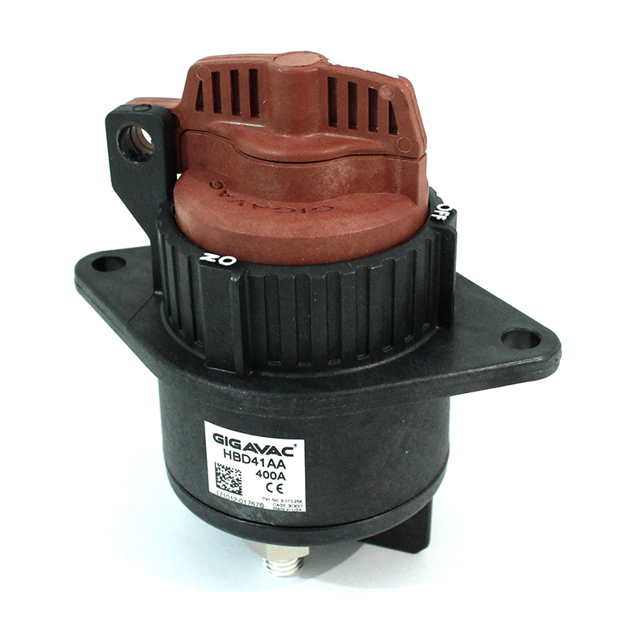
- Flip the 12V switch (it is labelled for you, the top one)
- Insert the deadman key.
- Flip the charge switch on (labelled for you)
- Remove and re-insert the deadman key.
- Doublecheck that the Jet Ski is now in charge mode by looking at the ZEVA monitor, which should have a blue banner that reads “EVMS: Charging” at the top.
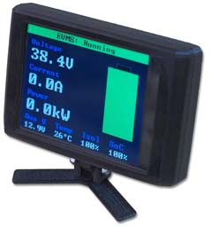
- Plug in the charger, which will audibly start if everything has been done correctly.
- Once charging is finished, the Jet Ski will beep and the charger will automatically stop.
- Flip all the switches off (Rotary switch, 12V switch, charge switch), then remove the deadman key and return it to the safe.

