Adding Eyebot Tool Links & Icons for EditPlus

1. Open EditPlus/Tools/Configure User Tools

2. Fill in the following fields and checkboxes and press Add to add the GNU compiler
tool icon to your toolbar
gcc68 Compiler
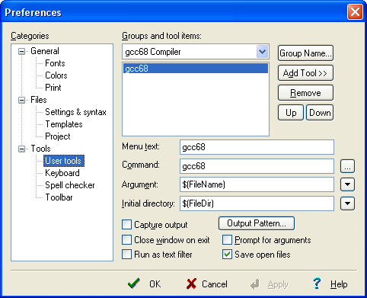
Menu: gcc68

Command: c:\eyebot\mcXX\cmd\windows\gcc68.bat

3. Repeat step 2 for adding the HDT compiler script to the toolbar
Menu text: gcchdt HDT Compiler
Command: c:\eyebot\mcXX\cmd\windows\gcchdt.bat %n

4. Repeat step 2 for adding the download link to the toolbar
Menu text: Download
Command: c:\eyebot\mcXX\cmd\windows\dl.bat %p%n

