Adding Eyebot Tool Links & Icons for UltraEdit 32

1. Open UltraEdit/Extras/Tool configurator
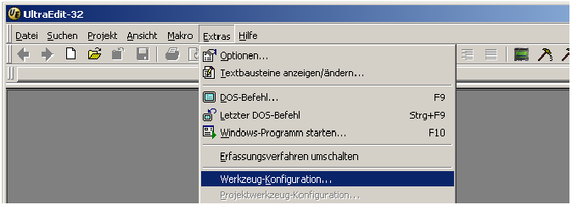

2. Fill in the following fields and checkboxes and press Add to add the GNU compiler
tool icon to your toolbar
c:\eyebot\mcXX\cmd\windows\gcc68.bat %n
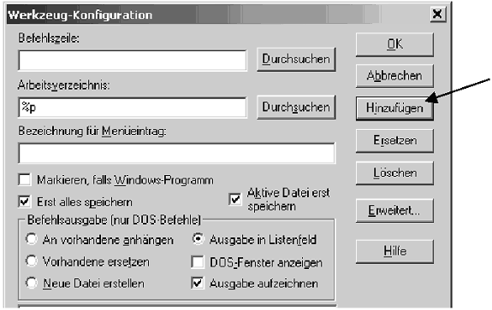
gcc68 Cross Compiler

3. Repeat step 2 for adding the HDT compiler script to the toolbar
Command: c:\eyebot\mcXX\cmd\windows\gcchdt.bat %n
Link name: gcchdt HDT Compiler

4. Repeat step 2 for adding the download link to the toolbar
Command: c:\eyebot\mcXX\cmd\windows\dl.bat %p%n
Link name: Download

5. For changing the icon of each link, click on “Advanced ...” and enter an *.ico file.

