# REV PROJECT JET SKI INFORMATION SHEET

*This sheet to be kept by inductee*

|  |  |
| --- | --- |
| **Instructor Name** | **Instructor Contact Information** |
|  |  |

|  |  |
| --- | --- |
| **Supervisor Name** | **Supervisor Contact Information** |
| Thomas Braunl |  |

## Driving an Electric Vehicle

Driving an electric vehicle is almost identical to driving a petrol/diesel equivalent. There are only a few differences to note.

**Before Driving the Jet Ski**

Check the following:

* The vehicle and you are in compliance with the vehicle usage procedures (R01).
* The driver holds a valid Recreational of Professional Skipper’s Ticket.
* You have read and understood the induction documents (F04).
* The vehicle is not charging, and the charging port has been sealed.
* You are wearing the jet ski safety vest and the deadman key is attached to the vest.
* The vehicle is sufficiently charged (see Battery Level).
* All box modules and battery tubes inside the jet ski are sealed.
* You have the ability to contact support if necessary (a mobile phone and contact information)

**Starting the Vehicle**

1. Turn power on via the main rotary switch.
2. Turn on 12V power, bilge pump, and cooling pump via the three switches next to the main rotary switch.
3. Insert the deadman key and attach the other side to your dafety vest.

**If the vehicle does not start check the following:**

* The deadman key is properly inserted.
* Plug in the ZEVA monitor to see if it detects any issues.

**Battery Level**

The REV Jet Ski runs off several packs of batteries in order to function. The battery charge can be checked either via the on-board battery monitor or by plugging in the ZEVA monitor.

Before driving, ensure the battery is as fully charged as possible. The Jet Ski will stop charging automatically once the batteries are at maximum charge, although this can be double with either monitor.

The on-board battery monitor has several different menus that can be scrolled through using the arrow buttons. It displays the following information:

* Battery Level: as a percentage symbol (%)
* Time: in hours (h)
* Battery pack voltage: in volts (V)
* Amperage: in amps (A)
* Amp hours: as amp hours (Ah)

The batteries used in the REV Jet Ski are supposed to degrade very slowly from full charge but take caution if the vehicle is left unused for a very long period of time. The voltage of the battery pack should not drop below a **minimum of 87V**, so in the event that the pack drops below this minimum, send a report to a REV instructor or project supervisor as soon as possible.

**Vehicle Charging**

The REV Jet Ski can be charged using the GWL Power Charger 96V/25A which is located in the REV Lab (G25 Civil and Mechanical Engineering). To charge, follow the given steps:

1. Plug in the ZEVA monitor.
2. Flip the main rotary switch on.

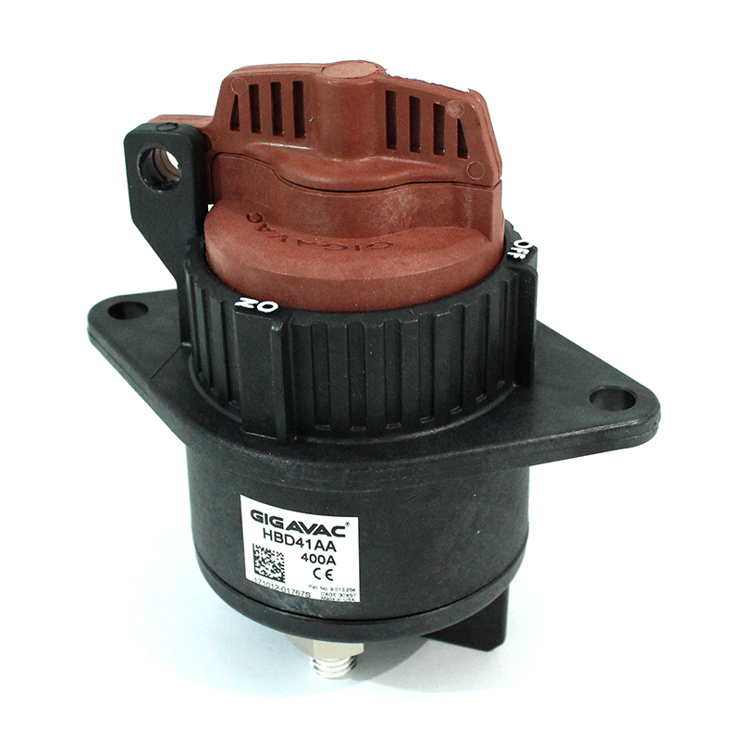

Figure 1: Main rotary switch

1. On the charging box module located in the front of the Jet Ski, flip its switch to set the vehicle into charging mode.
2. Doublecheck that the Jet Ski is now in charge mode by looking at the ZEVA monitor, which should have a blue banner that reads “EVMS: Charging” at the top.
3. Plug in the charger, which will audibly start if everything has been done correctly.
4. Once charging is finished, the Jet Ski will beep, and charging will automatically stop.
5. Flip the rotary switch off and disconnect charger.

If done correctly, the ZEVA monitor will indicate that the vehicle is in charging mode.

The charger itself is portable and can be plugged into any standard wall socket.

**Breakdown Procedures**

In the event the electric vehicle has broken down, contact a REV instructor or the REV Project supervisor. If they cannot be contacted, call the RAC on 131111.

**Emergency Procedures**

In the event of an emergency it is important put the lives of yourself and others first.

**Emergency Stop**

To perform an emergency stop, pull out the deadman key which will cut off the batteries to the vehicle. Note that this will automatically occur if you are separated from the vehicle during operation, provided the key is attached to you.