REV PROJECT HYDROFOIL JET SKI INFORMATION SHEET
This sheet to be kept by inductee

Instructor Name | Instructor Contact Information

Supervisor Name | Supervisor Contact Information
Thomas Bräunl

Driving an Electric Vehicle
Driving an electric vehicle is usually identical to driving a petrol/diesel equivalent. There are only a few differences to note. To ride the hydrofoil jet ski, rider must be appropriately inducted to do so.

Before Driving the Jet Ski
Check the following:
- The vehicle and you are in compliance with the vehicle usage procedures (R01).
- The driver holds a valid Recreational of Professional Skipper’s Ticket.
- You have read and understood the induction documents (F04).
- The vehicle is not charging, and the charging port is tucked away inside the battery box.
- Deutsch CAN plug from the display is connected to the battery box.
- You are wearing the jet ski safety vest and the deadman key is attached to the vest.
- You have a helmet to ensure safety and protection against any head trauma/injuries.
- The vehicle is sufficiently charged (check Battery Level).
- The battery box case inside the jet ski is closed and latched tight.
- You can contact support if necessary (a mobile phone and contact information).

Trailer loading/unloading

Trailer Loading:
- Ensure the rear mechanism is locked in ‘raised’ position.
- Ensure main switch is OFF and the Deadman is disconnected.
- Verify the jet ski is positioned exactly at the centre of the trailer and trailer strap is connected to the front of the jet ski.
- Secure the jet ski to the trailer at the rear using appropriate webbing straps.

Trailer Unloading:
- Ensure the rear mechanism is still locked in ‘raised’ position.
- Unlock and loosen the rear straps securing the jet ski to the trailer.
- Ease the jet ski from the trailer into water. Once the jet ski is in the water unlatch the strap connecting the front end of the ski to the trailer’s pulley.
- Guide the jet ski away from shore to the end of the jetty to a point where enough depth is available to allow lowering of the rear mechanism.
- Lower the rear mechanism into water.

Starting the Vehicle
- Turn power on by pulling out the red switch in the middle of the handlebar. Display should turn on at this stage.
- Insert the deadman key and attach the other side to your safety vest.

If the vehicle does not start check the following:
- The deadman key is properly inserted.
- The red switch in the middle of the handle is pulled out.
- Display switches on once the red switch is pulled.

Battery Level
The REV Jet Ski runs off several packs of batteries in order to function. The battery charge can be checked either via status indication on the display or by plugging in the ZEVA monitor bundled with the charger.

Before driving, ensure the ski is as fully charged as possible. The Jet Ski will stop charging automatically once the batteries are at maximum charge, although this can be double checked with either display or ZEVA display. Note that at any point in time only one of the two displays can be connected.

The batteries used in the REV Jet Ski are supposed to degrade very slowly from full charge but take caution if the vehicle is left unused for a very long period of time. The voltage of the battery pack should not drop below a minimum of 32V, so in the event that the pack drops below this minimum, send a report to a REV instructor or project supervisor as soon as possible.

Vehicle Charging
The REV Jet Ski can be charged using the T C charger (99V 80A output @220V AC) which is in the REV Lab (G25 Civil and Mechanical Engineering). To charge, follow the given steps:

- Ensure the main red switch in the middle of the handle is off, i.e., pushed in, and the Deadman switch is disconnected.
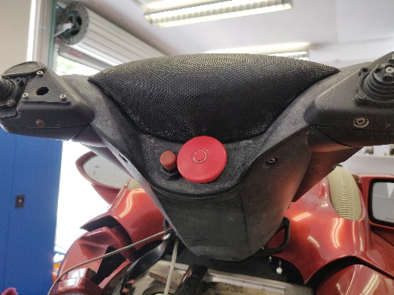
Figure 1: Main switch (right, bigger switch) and Deadman connection (left)
- Unplug the deutsch CAN Plug from the display to the battery box inside the jet ski is disconnected.
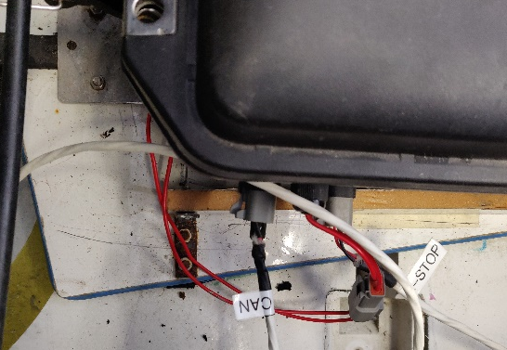
Figure 2: Deutsch CAN plug from display plugged in (left) and unplugged (right)
- Plug the deutsch CAN plug from the charger into the same slot as step 2 in the battery box.
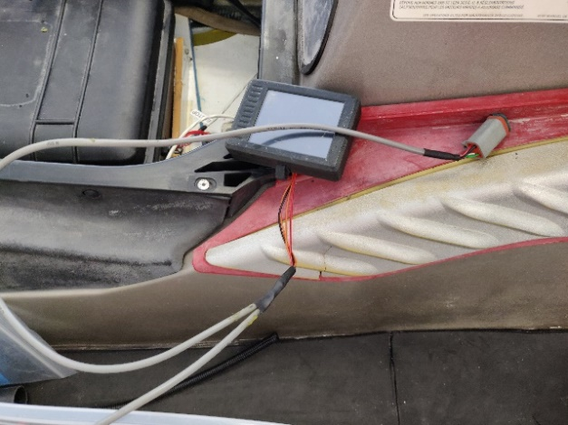
Figure 3: Deutsch CAN plug of the charger
- Open the battery box and pull out the female XT-90 connector present. Connect this to the male XT-90 connecter from the charger.
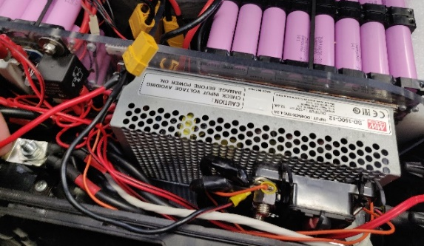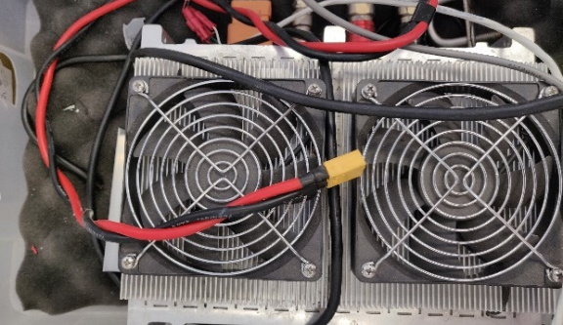
Figure 4: XT-90 Male female plug in battery box (left) and male plug in the charger (right)
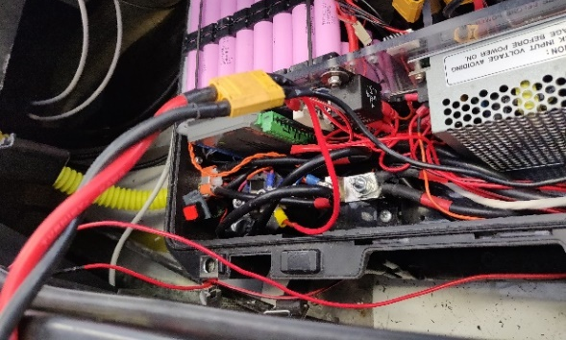
Figure 5: XT-90 connectors of charger and battery box connected together
- Connect the charger to mains and switch it on. ZEVA monitor will turn on at this stage and provide an indication of voltages, currents, and charge status.
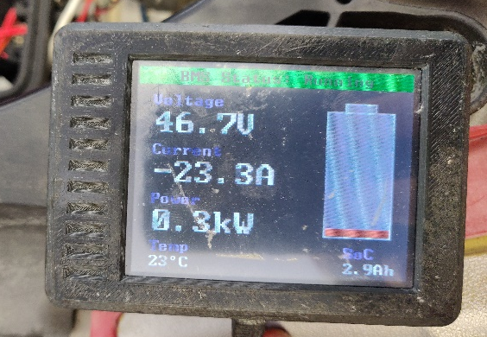
Figure 6: ZEVA monitor displaying voltage, current, and power on its first screen
- Once batteries are sufficiently charged, the BMS will beep and stop charging.
The charger itself is portable and can be plugged into any standard wall socket. Once charging is complete, disconnect XT-90 connection, unplug deutsch CAN plug of the charger from the battery box, connect deutsch CAN plug from the display to the battery box, and ensure display switches on when main red switch on handle is pulled.

Breakdown Procedures
In the event the electric vehicle has broken down, contact a REV instructor or the REV Project supervisor. If they cannot be contacted, call the Australian Maritime Safety Authority (AMSA) on 1800 627 484.

Emergency Procedures
In the event of an emergency it is important put the lives of yourself and others first.

Emergency Stop
To perform an emergency stop, pull out the deadman key which will cut off the batteries to the vehicle. Note that this will automatically occur if you are separated from the vehicle during operation, provided the key is attached to you.

